8.79: a Using the notation of Eq. 8.24

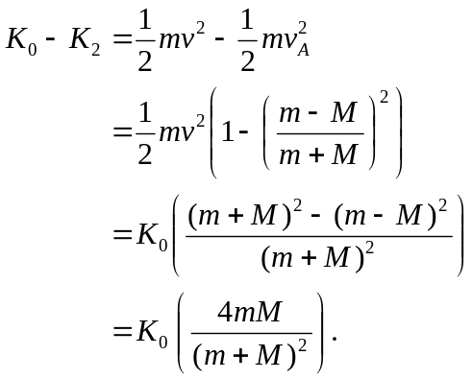

b) Of the many ways to do this calculation, the most direct way is to differentiate the expression of part (a) with respect to M and set equal to zero;
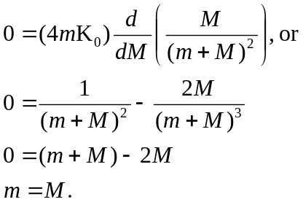

c) From Eq.(8.24), with 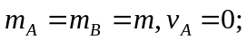 the neutron has lost all of its kinetic energy.

